**Sir Syed University of Engineering & Technology (SSUET) Computer Engineering Department**

## DATABASE MANAGEMENT SYSTEM

**Semester: 5th**

**Section:A**

**Batch: 2021F PROJECT REPORT**

## Project Title:

**Trendmine with Datamining**



## Submitted By:

**M. Faizan 2021F-BCE-093**

**Syed Shahnoor Hasan 2021F-BCE-098**

**Adbul Moiz Ansari 2021F-BCE-142**

**Maryam Ali Asghar 2021F-BCE-239**

## Submitted To:

**Miss Faiza Farooq**

# Sir Syed University of Engineering and Technology Computer Engineering Department

**Report Index**

|  |  |
| --- | --- |
| **S.NO** | **TOPICS** |
| 1 | Acknowledge |
| 2 | Abstract |
| 3 | Introduction |
| 4 | Methodology |
| 5 | Result (OUTPUT) |
| 6 | Conclusion |
| 7 | Reference |

**School Management System**

# Acknowledgements:

We would like to express my sincere gratitude and appreciation to all those who have contributed to the successful completion of this project report. First and foremost, We am deeply thankful to my teachers Miss Faiza Farooq , for their guidance, support, and invaluable insights throughout the project. Their expertise and encouragement have been instrumental in shaping the direction and quality of this report. We would also like to express my gratitude to my fellow classmates and colleagues who have provided valuable insights and feedback throughout the project. Their constructive criticism and brainstorming sessions have significantly contributed to the improvement of this report. In conclusion, we are deeply grateful to everyone who has contributed directly or indirectly to the completion of this project report. Your support, guidance, and encouragement have been invaluable, and we are truly appreciative of your contributions.

Thank you.

# Abstract

This project introduces a feature-rich e-commerce platform with user-friendly interfaces for both admins and users. Developed using HTML, CSS, JavaScript, and integrated by PHP, the system seamlessly integrates with Microsoft SQL Server Management Studio to ensure efficient database management. The project stands out by incorporating data mining techniques to create personalized discount offers and identify trending products, optimizing user experience and boosting sales.

The platform's user interface is designed to be responsive, providing a seamless shopping experience across various devices. The admin panel enables efficient management of products, user accounts, and order processing. Advanced algorithms analyze user behavior, historical data, and market trends to generate personalized discounts, while real-time sales data is used to identify trending products.

Microsoft SQL Server Management Studio is employed for robust database management, ensuring data integrity and security. The project also includes comprehensive database modeling using Entity-Relationship Diagrams (ERD) with mapping and normalization techniques. This ensures efficient data organization and retrieval.

The integration of the database with Visual Code enhances system connectivity, facilitating smooth data flow between the frontend and backend. This project showcases the potential of data mining and intelligent algorithms to provide users with tailored discounts and trending product recommendations, resulting in an innovative and competitive e-commerce platform prioritizing user satisfaction and maximizing sales opportunities.

# Introduction

# The ever-evolving landscape of e-commerce demands innovative solutions that go beyond conventional platforms. This report presents the development of "Trendmine," a dynamic e-commerce platform that stands out through its integration of data mining techniques. The system is designed to provide users with a personalized shopping experience, featuring intelligent discount strategies and real-time identification of trending products.

# Built using HTML, CSS, JavaScript, and PHP, Trendmine seamlessly integrates with Microsoft SQL Server Management Studio for robust database management. The project leverages advanced algorithms to analyze user behavior, historical data, and market trends, resulting in the generation of personalized discounts and dynamic trending product suggestions.

# This introduction provides an overview of Trendmine's objectives, highlighting its commitment to offering a user-centric e-commerce experience. By combining the power of data mining with a responsive interface and efficient database management, Trendmine aims to set new standards in the e-commerce realm, prioritizing user satisfaction and maximizing sales opportunities.

# Methodology:

* 1. **Database Schema:**

**Total tables:100+**

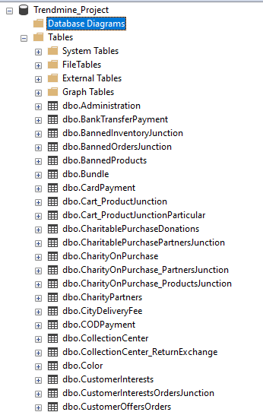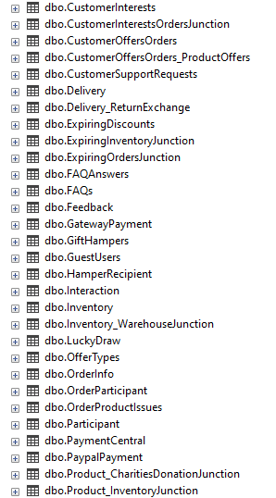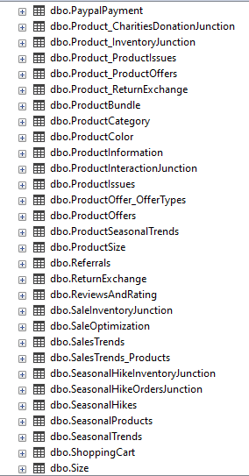

**ERD (with relational mapping):**

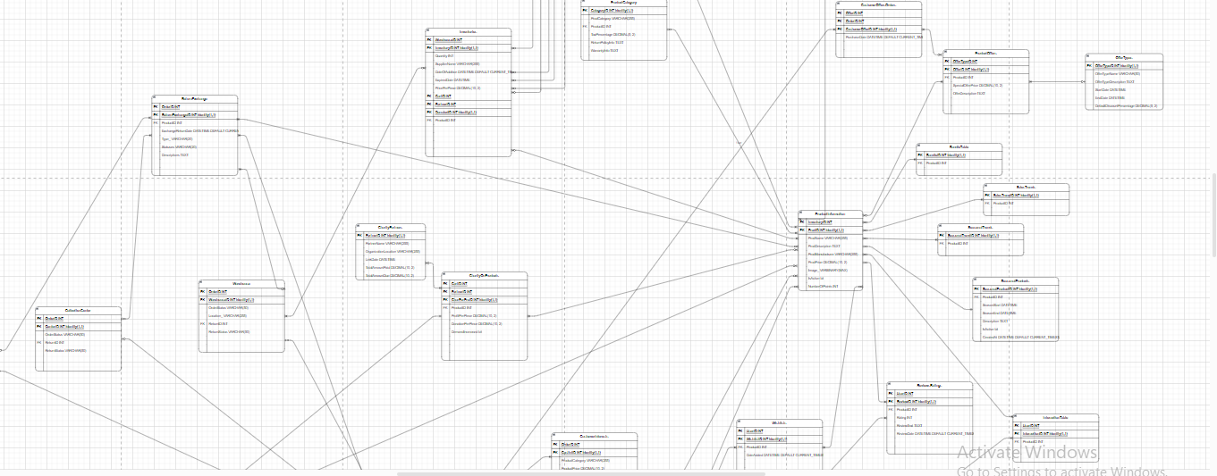

**Scan the qr code to View the complete EER diagram**



* 1. **Normalization:**

The normalization of a database involves organizing its tables and columns to reduce redundancy and dependency.

**First Normal Form (1NF):**

All tables comply with 1NF as they have atomic values in each column.

**Second Normal Form (2NF):**

The database is not fully in 2NF. The **ProductInformation** table has non-prime attributes (like **TaxPercentage**, **ReturnPolicyInfo**, and **WarrantyInfo**) that depend on only part of the primary key. These attributes can be moved to a separate table to achieve 2NF.

**Third Normal Form (3NF):**

The database is not fully in 3NF. The **ProductInformation** table has transitive dependencies. The non-prime attributes mentioned above can be moved to a separate table, linking them directly to their respective keys to achieve 3NF.

* 1. **Theoretical description with definitions:**

**1. Project Overview:**

The project encompasses the development of a comprehensive e-commerce platform named "Trendmine." This platform is designed to offer users a personalized and dynamic shopping experience, leveraging data mining techniques for intelligent discounting, trend identification, and user behavior analysis.

**2. Database Structure:**

The database underlying Trendmine is structured to manage various aspects of an e-commerce ecosystem. It consists of tables representing entities such as user profiles, sessions, products, orders, payments, inventory, and more. The tables are designed to establish relationships and capture interactions between different components of the system.

**3. Entity-Relationship Model (ERD):**

The database follows the principles of the Entity-Relationship Model, where entities (such as users, products, orders) are represented as tables, and relationships between entities are established through foreign keys. This model facilitates a clear understanding of the relationships and dependencies within the database.

**4. Normalization:**

The database has undergone normalization to ensure data integrity and eliminate redundancy. Each table is in the First Normal Form (1NF), and normalization techniques like Entity-Relationship Diagrams (ERD) with mapping and normalization have been applied. This helps in organizing data efficiently, reducing data duplication, and maintaining consistency.

**5. Data Mining Techniques:**

The project incorporates data mining techniques to analyze user behavior, preferences, and market trends. Advanced algorithms are employed to generate personalized discount offers, identify trending products, and enhance the overall user experience. This data-driven approach aims to boost sales and user satisfaction.

**6. User-Centric Features:**

Trendmine focuses on user-centric features, offering a responsive and intuitive user interface for both administrators and regular users. The inclusion of personalized discounts, trending offers, wishlists, reviews, and charitable contributions contributes to a holistic and engaging shopping experience.

**7. Connectivity and Integration:**

The database is integrated seamlessly with the Trendmine platform, utilizing languages such as HTML, CSS, JavaScript, and PHP for frontend development. Microsoft SQL Server Management Studio is employed for robust database management, and Visual Code facilitates the connection between the frontend and backend.

**8. System Optimization:**

The design of the system includes considerations for optimization, performance, and scalability. Junction tables are introduced to manage many-to-many relationships, ensuring a relational structure that can accommodate a diverse range of features and functionalities.

**9. Charitable Contributions and Social Responsibility:**

The project introduces features for charitable contributions with partnerships, donations, and campaigns. This reflects a commitment to social responsibility, allowing users to participate in charitable activities through their purchases.

**10. Future Directions:**

The modular and extensible design of the project opens possibilities for future enhancements and expansions. It provides a foundation for continuous improvement, adaptability to emerging trends, and the incorporation of additional features to meet evolving user needs in the dynamic e-commerce landscape.

1. **Result (output):**

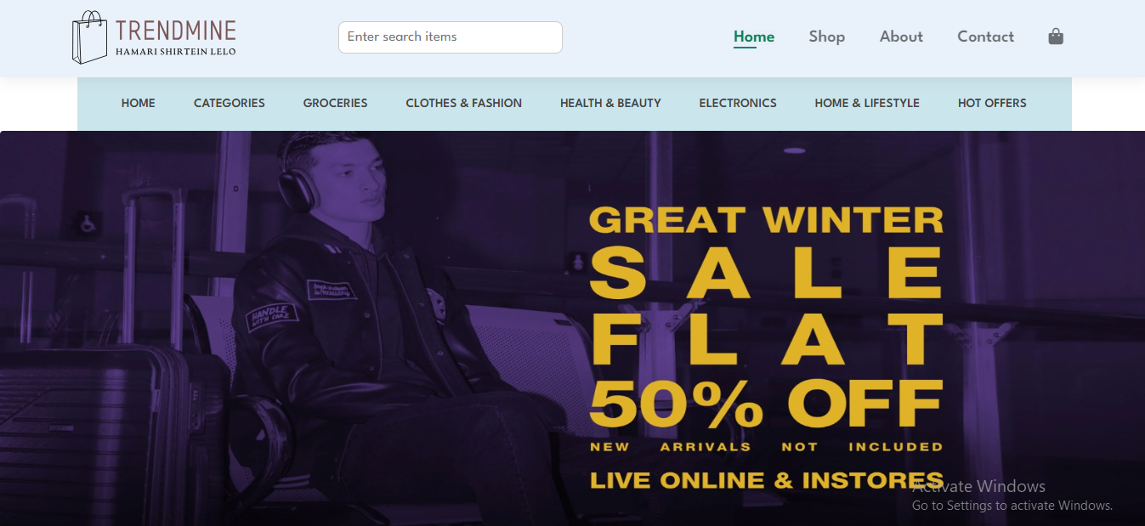

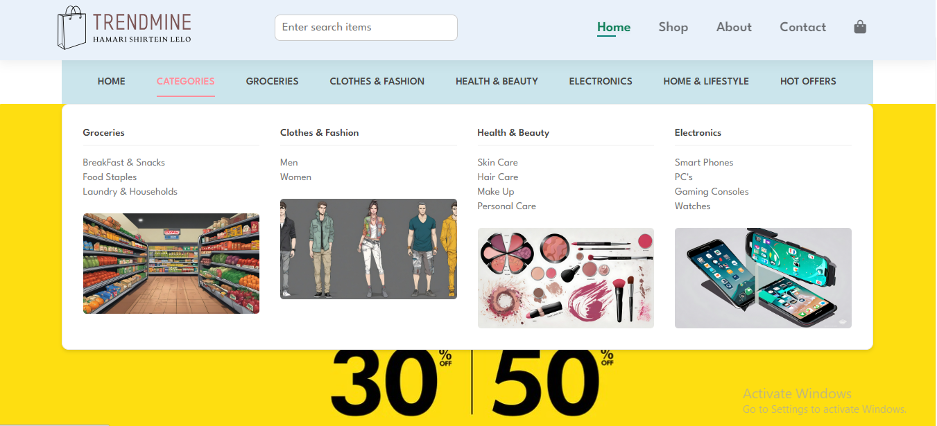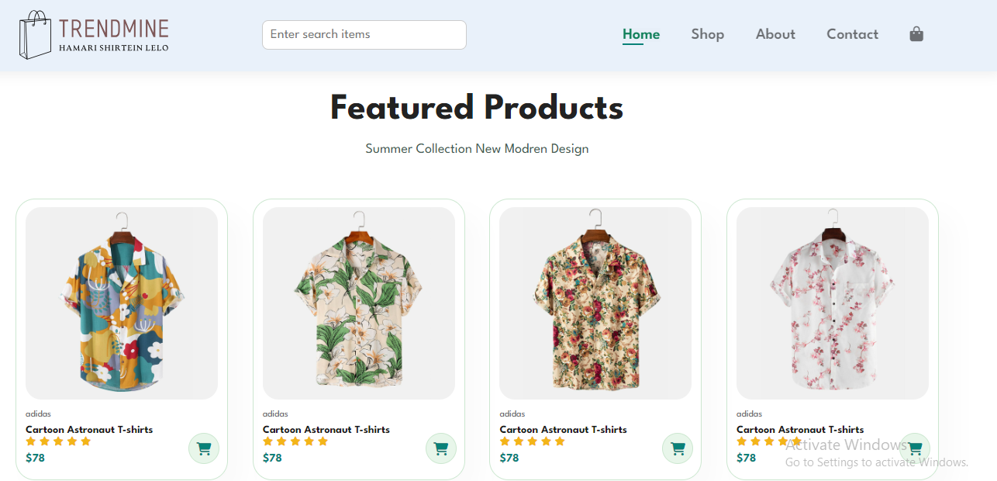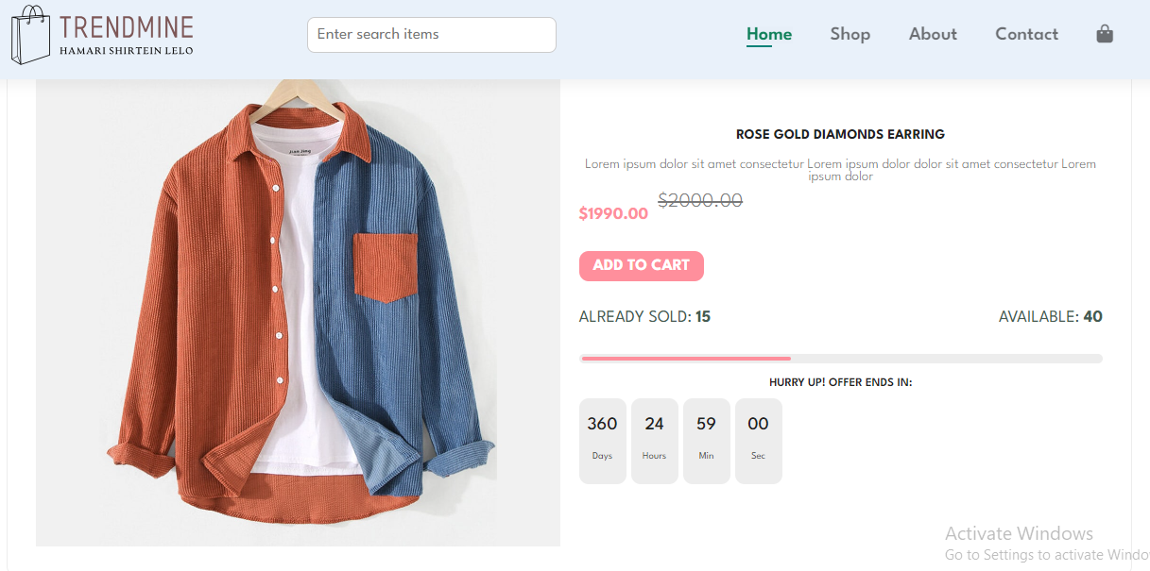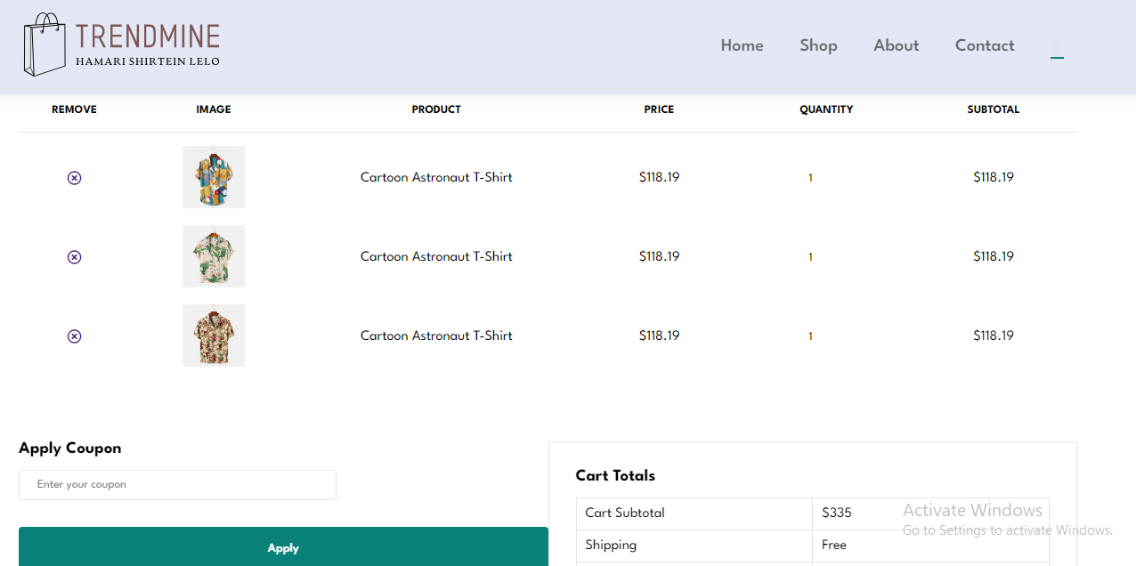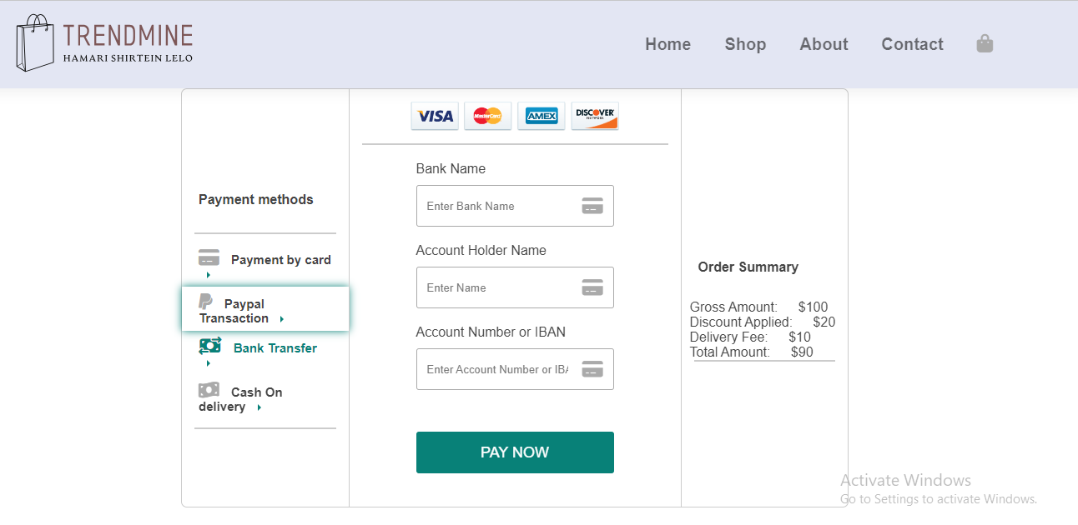

1. **Conclusions:**

The conclusions and recommendations section summarizes the project insights gained from developing the School Management System. It emphasizes the system's potential advantages, including enhanced administrative efficiency, accurate student data management, and improved user satisfaction. Key recommendations include conducting thorough testing to ensure seamless functionality, implementing stringent security measures to safeguard sensitive student information, and providing comprehensive training to school staff for seamless system integration.

# Reference:

* Chat GPT
* Freepik Image AI